Portugal

[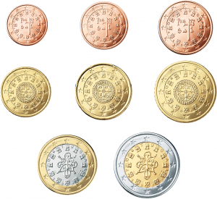](http://eltamiz.com/elcedazo/wp-content/uploads/2013/04/Portugal-Euro.png)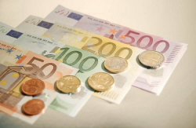 Currency Euro

|  |  |  |
| --- | --- | --- |
| €1 = | £ | 0.7986 |

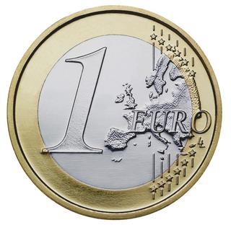How many Euros in a pound

Hasan Gursoy