Mince pies
Ingredients  240g plain flour  60g block margarine  60g white fat  Approx. 4 tablespoons water  Approx. 150g sweet mince  A little milk | Equipment  Mixing bowl Knife  Bun tin Sieve  Rolling pin Teaspoon  Dessert spoon  Measuring jug  Pastry brush  Cutters – circle & star | 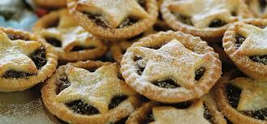

Method
Step | Process
1 | Wash your hands, put an apron on and collect your equipment. | 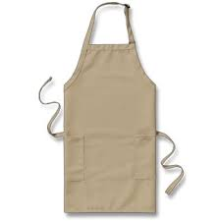
2 | Put the oven on to 200˚C. | 200˚C
3 | Weigh the flour and sieve into a mixing bowl. | 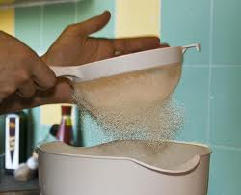
4 | Weigh the margarine and white fat. Cut them into little pieces and add to the flour. | 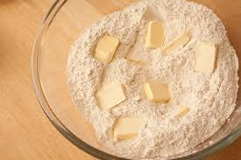
5 | Rub the margarine and white fat into the flour using your fingertips – remember not to rub too much, it’s ok to still have some lumps in the mixture. | 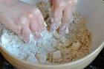
6 | Add 4 table spoons of water and stir with a knife.
7 | Use one hand to try to make the mixture into a ball. If it is too dry, add a little more water but check with the teacher. | 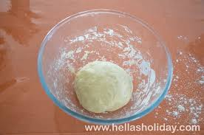
8 | When you have a ball of mixture, put it onto a floured table. Cut the pastry in half. | 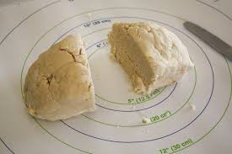
9 | Roll out one piece of pastry. Use flour on the table and on top of the pastry to stop it sticking. Cut out circles using a cutter and fit them into the bun tin. You should make 12. | 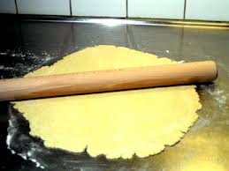
10 | Put a small amount of sweet mince onto each pastry circle. | 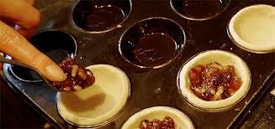
11 | Roll out the second piece of pastry and cut out star shapes. Put them on top of the sweet mince. | 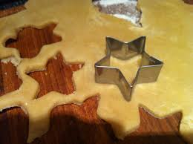
12 | Gently brush a little milk over the pastry stars.
13 | Put your mince pies into the oven for about 10 minutes until they are crisp and light golden brown. (do not try to taste the mince pies when they come out of the oven – the sweet mince will be very hot).
14 | Wash up and tidy away.
15 | When the mince pies are cool, you could dust them with icing sugar to improve the presentation. | 