Notes

Danish Currency

[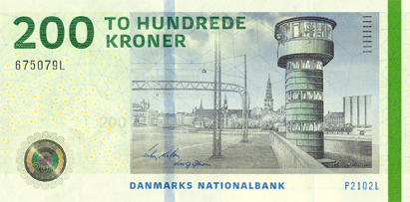](http://upload.wikimedia.org/wikipedia/en/f/fc/DKK_200_obverse_(2009).jpg)[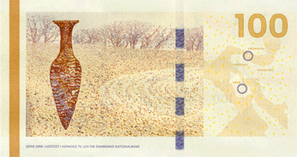](http://upload.wikimedia.org/wikipedia/en/d/d5/DKK_100_reverse_(2009).jpg)[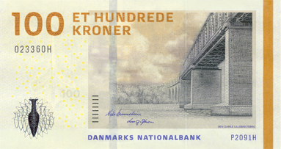](http://upload.wikimedia.org/wikipedia/en/7/7a/DKK_100_obverse_(2009).jpg)[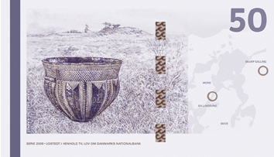](http://upload.wikimedia.org/wikipedia/en/a/ae/DKK_50_reverse_(2009).jpg)[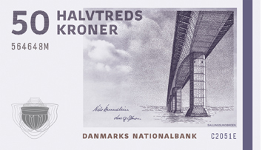](http://upload.wikimedia.org/wikipedia/en/7/71/DKK_50_obverse_(2009).jpg)

[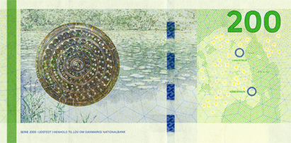](http://upload.wikimedia.org/wikipedia/en/a/a8/DKK_200_reverse_(2009).jpg)

[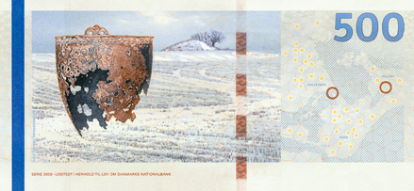](http://upload.wikimedia.org/wikipedia/en/d/d1/DKK_500_reverse_(2009).jpg)[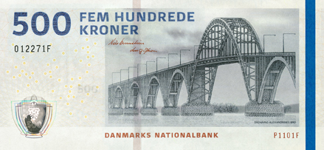](http://upload.wikimedia.org/wikipedia/en/b/b5/DKK_500_obverse_(2009).jpg)

[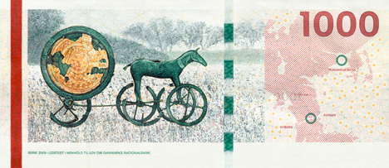](http://upload.wikimedia.org/wikipedia/en/b/b7/DKK_1000_reverse_(2009).jpg)[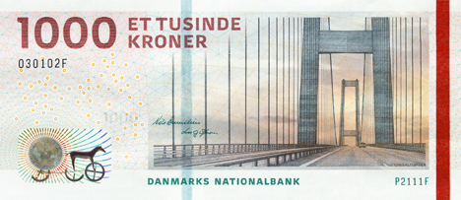](http://upload.wikimedia.org/wikipedia/en/d/de/DKK_1000_obverse_(2009).jpg)

Coins

[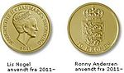](http://en.wikipedia.org/wiki/File:10_kroner_coin_2011-.jpg)[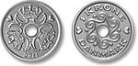](http://en.wikipedia.org/wiki/File:1_krone_coin.jpg)[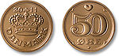](http://en.wikipedia.org/wiki/File:50_%C3%B8re_coin.jpg)

A [tin](http://en.wikipedia.org/wiki/Tin)-[bronze](http://en.wikipedia.org/wiki/Bronze) [50-øre](http://en.wikipedia.org/wiki/Fifty_%C3%B8re_(Danish_coin)) coin

A [tin](http://en.wikipedia.org/wiki/Tin)-[bronze](http://en.wikipedia.org/wiki/Bronze) [50-øre](http://en.wikipedia.org/wiki/Fifty_%C3%B8re_(Danish_coin)) coin

A [cupronickel](http://en.wikipedia.org/wiki/Cupronickel) [1-krone](http://en.wikipedia.org/wiki/Krone_(Danish_coin)) coin

An [aluminium bronze](http://en.wikipedia.org/wiki/Aluminium_bronze) 10-kroner coin (2011- series)