BTEC Skills for independence and work

**Unit 7: Using Public Transport**

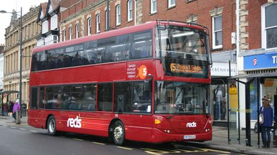The aim of this unit is to help you to learn how to access and use public transport in the Middlesbrough area.

Being able to use public transport is a skill that aids independence and builds confidence. This unit aims to give you the confidence and knowledge to travel.

**For learning outcome 1**

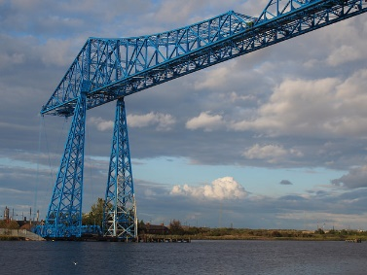

* You will develop the skills to use public transport by planning a trip.
* These skills include reading simple timetables, route maps and purchasing their tickets.
* You will discuss and identify expected behaviour, e.g. queuing and not putting feet on the seats.

**For learning outcome 2**

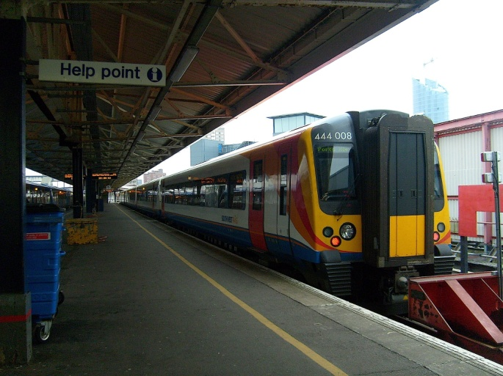You will have the opportunity to put your new knowledge and skills into action by planning and making a trip on public transport.

After the trip you will review your experience of using public transport.

**Task 1: Describe the advantages and disadvantages of the following forms of public transport found in the local area**

|  |  |  |
| --- | --- | --- |
| **Method** | **Advantages** | **Disadvantages** |

|  |  |  |
| --- | --- | --- |
| **http://www.thejetsetter.co.uk/hpbimg/rails4/170305soton.jpgTrain** |  |  |
|  |  |
|  |  |
|  |  |

|  |  |  |
| --- | --- | --- |
| http://cdn2.shipspotting.com/photos/middle/8/1/5/1679518.jpg**Ferry** |  |  |
|  |  |
|  |  |
|  |  |

|  |  |  |
| --- | --- | --- |
| **http://ivory.vnunet.com/images/transport/aeroplane/medium.jpgPlane** |  |  |
|  |  |
|  |  |
|  |  |

|  |  |  |
| --- | --- | --- |
| Bus  http://assets.goaheadbus.com/media/cms_page_media/686/IMG75667%20WD%201132%20HF09BJE%20Salisbury%207%20Jan%2014.JPG.386x216_q85_crop-smart.jpg |  |  |
|  |  |
|  |  |
|  |  |

**Task 2: Describe how to travel using public transport**

*Criteria covered: 1.1 Describe how to get from one place to another using public transport*

1. Identify the different ways we can get information about routes, times and prices for different modes of public transport in the local area

|  |
| --- |
| ________________________________________________________________________________________________________________________________________________________________________________________________________________________________________________________________________________________________________________________________________________ |

1. We have identified different forms of public transport in the local area. Use this information to help you describe the following journeys using different forms of public transport. Include the following:

* Departure and arrival times
* What mode of transport you used
* The cost of a return journey

|  |  |  |  |
| --- | --- | --- | --- |
| **Journey 1: Saltersgill to Middlesbrough** | | | |
| Depart Saltersgill |  | Depart Middlesbrough |  |
| Arrive Middlesbrough |  | Arrive Saltersgill |  |
| Journey Time |  | Journey time |  |
| Cost of an adult return | £ | | |
| |  |  |  |  | | --- | --- | --- | --- | | **Journey 2: Middlesbrough to Redcar** | | | | | Depart Middlesbrough |  | Depart Redcar |  | | Arrive Redcar |  | Arrive Middlesbrough |  | | Journey Time |  | Journey Time |  | | Cost of an adult return | £ | | | | | | | | |
| |  |  |  |  | | --- | --- | --- | --- | | **Journey 3: Middlesbrough to Saltburn** | | | | | Depart Middlesbrough |  | Depart Saltburn |  | | Arrive Saltburn |  | Arrive Middlesbrough |  | | Journey Time |  | Journey Time |  | | Cost of an adult return | £ | | | | | | | | |

|  |  |  |  |  |  |  |  |  |  |  |  |  |  |  |  |  |  |  |  |  |
| --- | --- | --- | --- | --- | --- | --- | --- | --- | --- | --- | --- | --- | --- | --- | --- | --- | --- | --- | --- | --- |
| |  |  |  |  | | --- | --- | --- | --- | | **Journey 4: Saltersgill to North Ormesby** | | | | | Depart Saltersgill |  | Depart North Ormesby |  | | Arrive North Ormesby |  | Arrive Saltersgill |  | | Journey Time |  | Journey Time |  | | Cost of an adult return | £ | | | |

**Task 3: Show that you know how to behave when using public transport**

*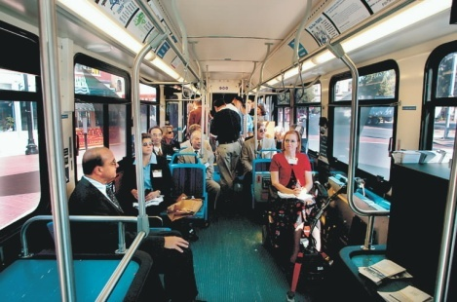Criteria Covered: 1.2 Identify expected behaviour when using public transport*

When using public transport it is important that we all know how to behave appropriately.

1. Identify **three** examples of expected behaviour when using public transport and explain why each expected behaviour is important.

* ........................................................................................................................................................................................................................................................................................................................................................................................................................
* ........................................................................................................................................................................................................................................................................................................................................................................................................................
* ........................................................................................................................................................................................................................................................................................................................................................................................................................

2. Discuss the examples below of inappropriate behaviour when using public transport. Identify what could happen to the people involved.

1. 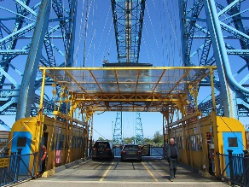A young boy trying swinging on the handrails on the Transporter Bridge .................................................................................................................................................................................................................................................................................................................................

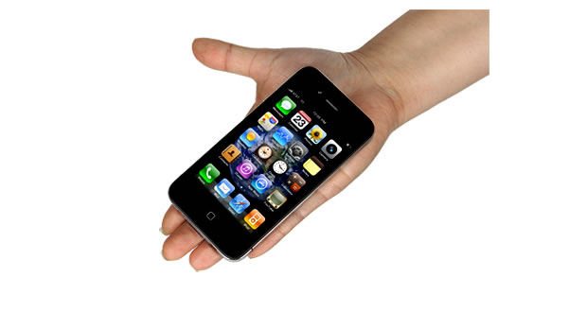ii) A student alone on the top deck of the X7 bus at 10.30pm using her iphone to listen to music. ..............................................................................................................................................................................................................................................................................................................................

**Task 4: Dealing with hazards and risks when using public transport**

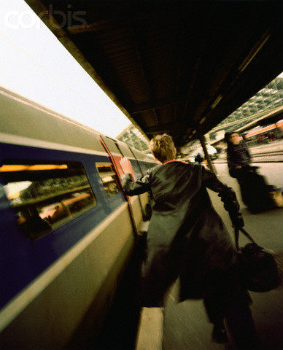For this task you will be identifying potential hazards when using all forms of public transport including Bus, train, ferry and planes.

Look at this picture and talk about the:

1. **Potential hazard caused by the man.**
2. **The risk to the man’s health**
3. **An appropriate action to deal with the hazard.**
4. Using the computer make a poster to show the potential hazards when using public transport in the Middlesbrough area. Include images that represent the different hazards or forms of transport.

*(Criteria covered: 1.3 identify potential hazards when using public transport)*

1. Then identify how you can minimise the risk caused by each hazard and make using public transport much safer.

*(Criteria covered 1.4 select appropriate actions to deal*

*with potential hazards when using public transport)*

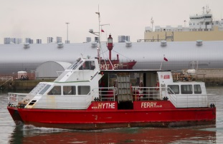

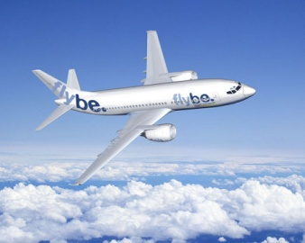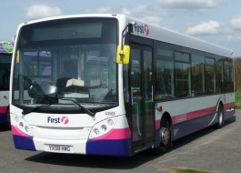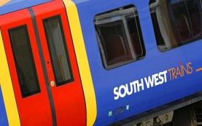

**Task 5: Planning a trip using public transport**

*Criteria covered: 1.5 Use travel information to plan a trip on public transport*

Destination: ______________________________________

Reason for visiting: _________________________________

**Outward Journey**

|  |  |  |  |
| --- | --- | --- | --- |
| **Place** | **Departure time** | **Mode of transport** | **Arrival time** |
|  |  |  |  |
|  |  |  |  |
|  |  |  |  |
|  |  |  |  |
|  |  |  |  |

**Time spent at chosen destination before returning back to school …………………………………………………………………………………………………………………………………………….**

**Return Journey**

|  |  |  |  |
| --- | --- | --- | --- |
| **Place** | **Departure time** | **Mode of transport** | **Arrival time** |
|  |  |  |  |
|  |  |  |  |
|  |  |  |  |
|  |  |  |  |
|  |  |  |  |

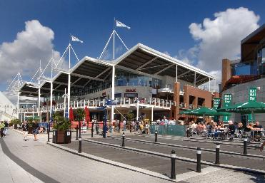**Task 6: Reviewing our trip to Newcastle**

Last week we travelled by public transport to Newcastle. Discuss your day out and answer the following questions using full sentences.

***Criteria Covered 2.1 Arrive at the correct departure point***

1. 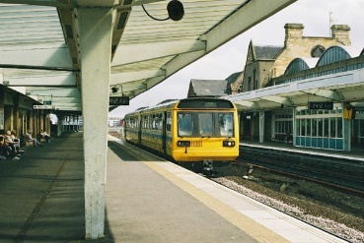Describe how you got to Middlesbrough Railway Station ………………………………………………………………………………………………………………………………………………………………………………………………………………………………………………………………………………………………………………………………………………………………………………………………………………………………………………………………………………………………
2. How long did it take to get to the ticket office? ………………………………………………………………………………………………………………………………
3. Describe any hazards that you saw. ………………………………………………………………………………………………………………………………………………………………………………………………………………………………………………………………

***Criteria Covered 2.2 Have the correct ticket or money to buy ticket.***

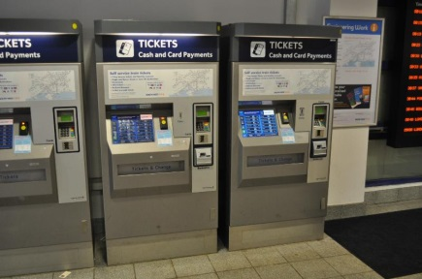

1. [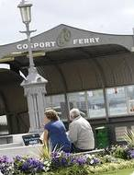](http://www.google.co.uk/imgres?imgurl=http://www.go-gosport.co.uk/assets/Image/image12.jpg&imgrefurl=http://www.go-gosport.co.uk/pages/environmental-health/&usg=__aZNbJD-G8A9AAUto1nBBZUL0yJs=&h=300&w=231&sz=21&hl=en&start=25&zoom=1&tbnid=J9hvOvWJaxXXfM:&tbnh=144&tbnw=119&prev=/images?q=Gosport+ferry+ticket+office&um=1&hl=en&biw=1420&bih=762&tbs=isch:1&um=1&itbs=1&ei=pending&iact=hc&vpx=364&vpy=310&dur=219&hovh=190&hovw=146&tx=100&ty=71&oei=K0rdTKjGJ4qBhQfEu8niDA&esq=2&page=2&ndsp=24&ved=1t:429,r:1,s:25)Describe how you purchased your ticket ……[](http://www.google.co.uk/imgres?imgurl=http://www.go-gosport.co.uk/assets/Image/image12.jpg&imgrefurl=http://www.go-gosport.co.uk/pages/environmental-health/&usg=__aZNbJD-G8A9AAUto1nBBZUL0yJs=&h=300&w=231&sz=21&hl=en&start=25&zoom=1&tbnid=J9hvOvWJaxXXfM:&tbnh=144&tbnw=119&prev=/images?q=Gosport+ferry+ticket+office&um=1&hl=en&biw=1420&bih=762&tbs=isch:1&um=1&itbs=1&ei=pending&iact=hc&vpx=364&vpy=310&dur=219&hovh=190&hovw=146&tx=100&ty=71&oei=K0rdTKjGJ4qBhQfEu8niDA&esq=2&page=2&ndsp=24&ved=1t:429,r:1,s:25)………………………………………………………………………………………………………………………………………………………………………………………………………………………………………………………………………………………………………………………………………………
2. How much money was the ticket………………………………………………………………
3. What happened to the ticket when you boarded the train on the

**a) outward journey** ……………………..…………………………………………………………………………………………………………………………………………………………………………………………………………………………… and

b) **return journey** ………………………………………………………………………………………………………..………………………………………………………………………………………………………………………………………..

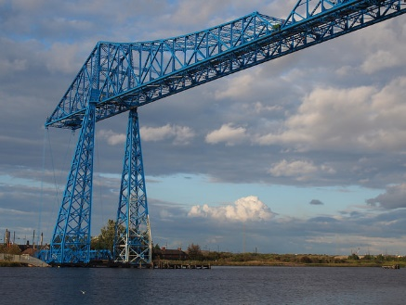***Criteria Covered 2.3 Describe how you travelled safely across the Transporter Bridge demonstrating appropriate behaviour.***

i) Describe 3 things that showed you travelled safely to Port Clarence and back to Middlesbrough.

1…………………………………………………………………………………………………………………………………………………………………………………………………………………………………………………………………………………………

2…………………………………………………………………………………………………………………………………………………………………………………………………………………………………………………………………………………………

3……………………………………………………………………………………………………………………………………………………………………………………………..……………………………………………………………………………………………

***Criteria Covered 2.4 Arrive at correct destination.***

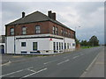

1. Did you reach the correct destination ………………………………………………………………………………………………………………………………………………………………………………………………………
2. Did you arrive at the estimated time …………………………………………………………………………………………………………………………
3. If your actual arrival time was different to your estimated time, explain why ……………………………………………………………………………………………………………………………………………………………………………………………………………………………………………………

***Criteria Covered 2.5 Comment on the outcome of the trip***

……………………………………………………………………………………………………………………………………………………………………………………………………………………………………………………………………………………………………………………………………………………………………………………………………………………………………………………………………………………………………………………………………………………………………………………

Mark Sheet

|  |  |
| --- | --- |
| Learners Name: | |
| Entry Level 2 – ***Unit 7 - Travelling: Using Public Transport*** | **Workbook Tasks 1-6 *–* *Plan, participate in and review a trip to a local leisure attraction using public transport.*** |
| Issue Date: | Due in Date: |
| Criteria met by task: ***1.1, 1.2, 1.3, 1.4, 1.5, 2.1, 2.2, 2.3, 2.4, 2.5*** | |

|  |  |  |
| --- | --- | --- |
| Criteria: | Assessors Comments: | *(Staff to tick, initial and date when complete)* |
| **1.1: Describe how to get from one place to another using a simple public transport map**   * *Identify the main types of transport in the local area* * *Identify the local bus stations, rail stations, ferry ports and airports.* * *Discuss the advantages and disadvantages of each mode of transport.* * *Use travel maps, timetables and the internet to describe how to travel from one place to another using public transport.* |  |  |
| **1.2: Identify expected behaviour when using public transport.**   * *Identify three examples of expected behavior when using public transport.* * *Explain why each expected behavior is important.* * *Explore what could happen to passengers displaying inappropriate behavior.* |  |  |
| **1.3 Identify potential hazards and 1.4 select appropriate actions to deal with potential hazards when using public transport.**   * *Identify some of the hazards that could occur when using public transport.* * *Describe the risks associated with each hazard.* * *Discuss ways to minimise the potential risk of each hazard.* |  |  |
| **1.5 use travel information to plan a trip on public transport**   * *Discuss which local leisure facility to visit.* * *Identify what modes of transport to use.* * *Use timetables work out departure and arrival times for each stage of the trip.* |  |  |
| **2.1 arrive at correct departure point** |  |  |
| **2.2 have the correct ticket or money to buy ticket** |  |  |
| **2.3 travel safely to the destination demonstrating appropriate behaviour** |  |  |
| **2.4 arrive at correct destination** |  |  |
| **2.5 comment on the outcome of the trip** |  |  |
| **Overall comments**: | | |

Interim assessment: Has the student met the following criteria for this assignment? (Y/N)

|  |  |  |  |  |  |  |  |  |  |
| --- | --- | --- | --- | --- | --- | --- | --- | --- | --- |
| 1.1 | 1.2 | 1.3 | 1.4 | 1.5 | 2.1 | 2.2 | 2.3 | 2.4 | 2.5 |
|  |  |  |  |  |  |  |  |  |  |

Assessor signature: Date:

Student signature: Date:

Internal Verifiers Signature: Date: