Famous places in the UK
In London

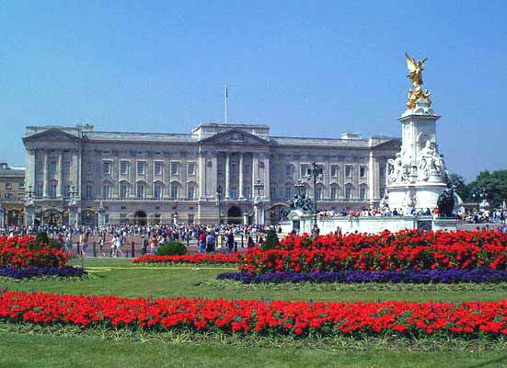

Buckingham Palace: The royal residence where Queen Elizabeth II lives with her husband and family.
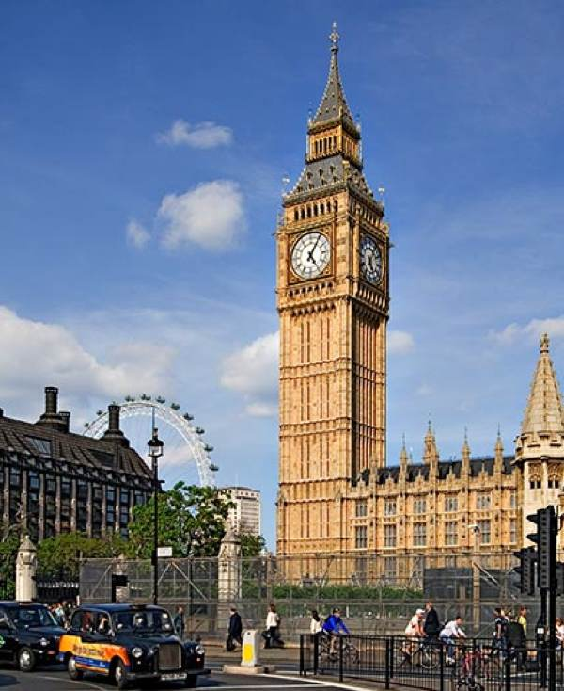
Big Ben and the Houses of Parliament:
Big Ben is actually the bell inside the clock tower. The British Government meets here in the Houses of Parliament.

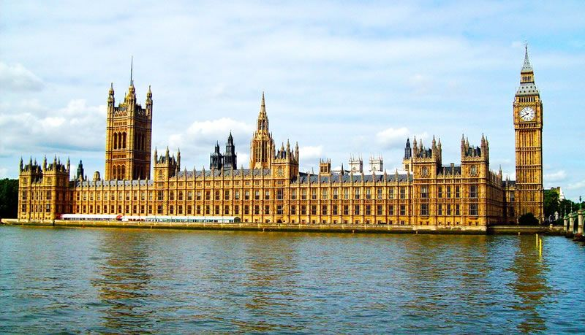
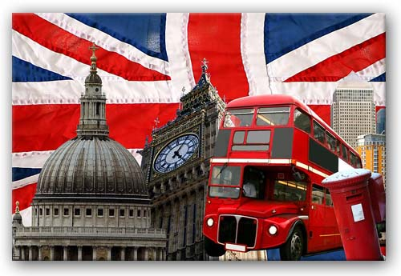
London is also famous for red buses, red post-boxes, the Union Jack Flag, St. Pauls cathedral, The Shard and Tower Bridge, as shown here.
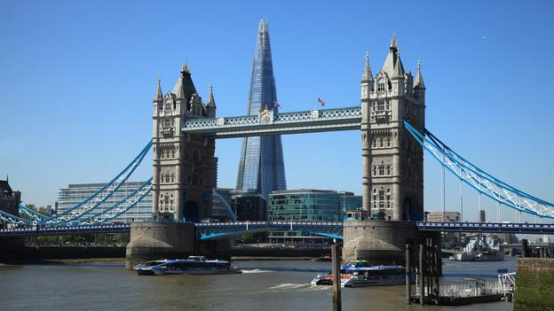

Other famous landmarks include:-
Stonehenge: An ancient stone circle near Salisbury
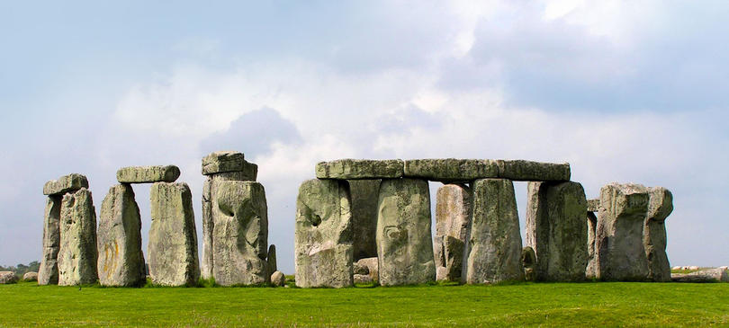

The Angel of the North: A steel statue near Newcastle in the North East of England. (That’s Wendy at the base)
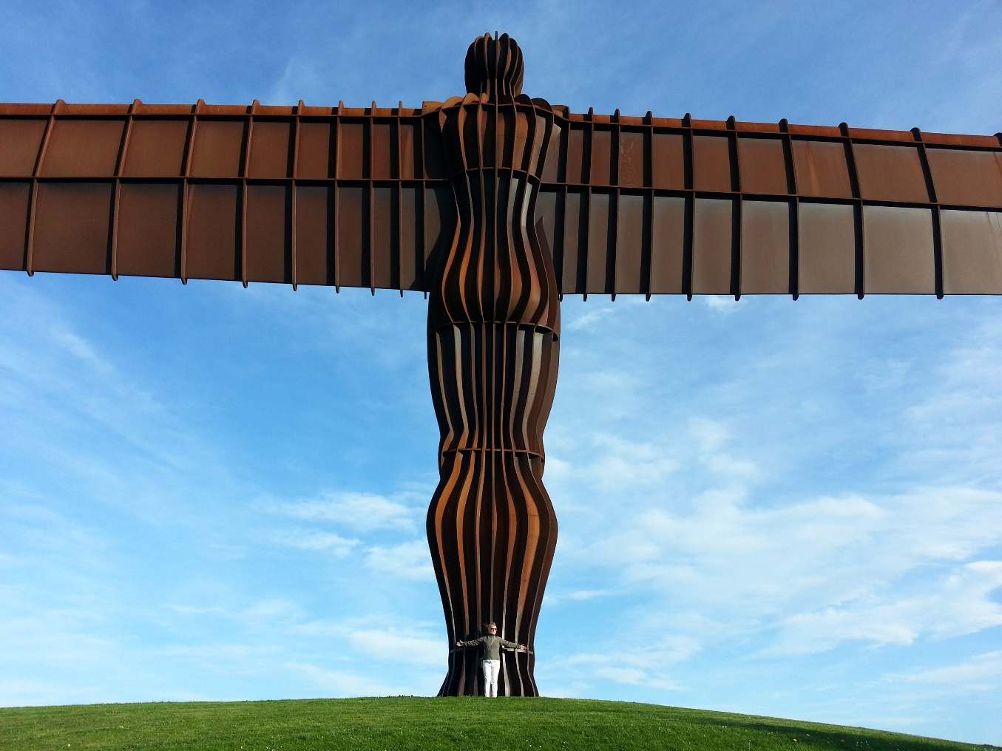
Bamburgh Castle: in Northumberland near to Newcastle
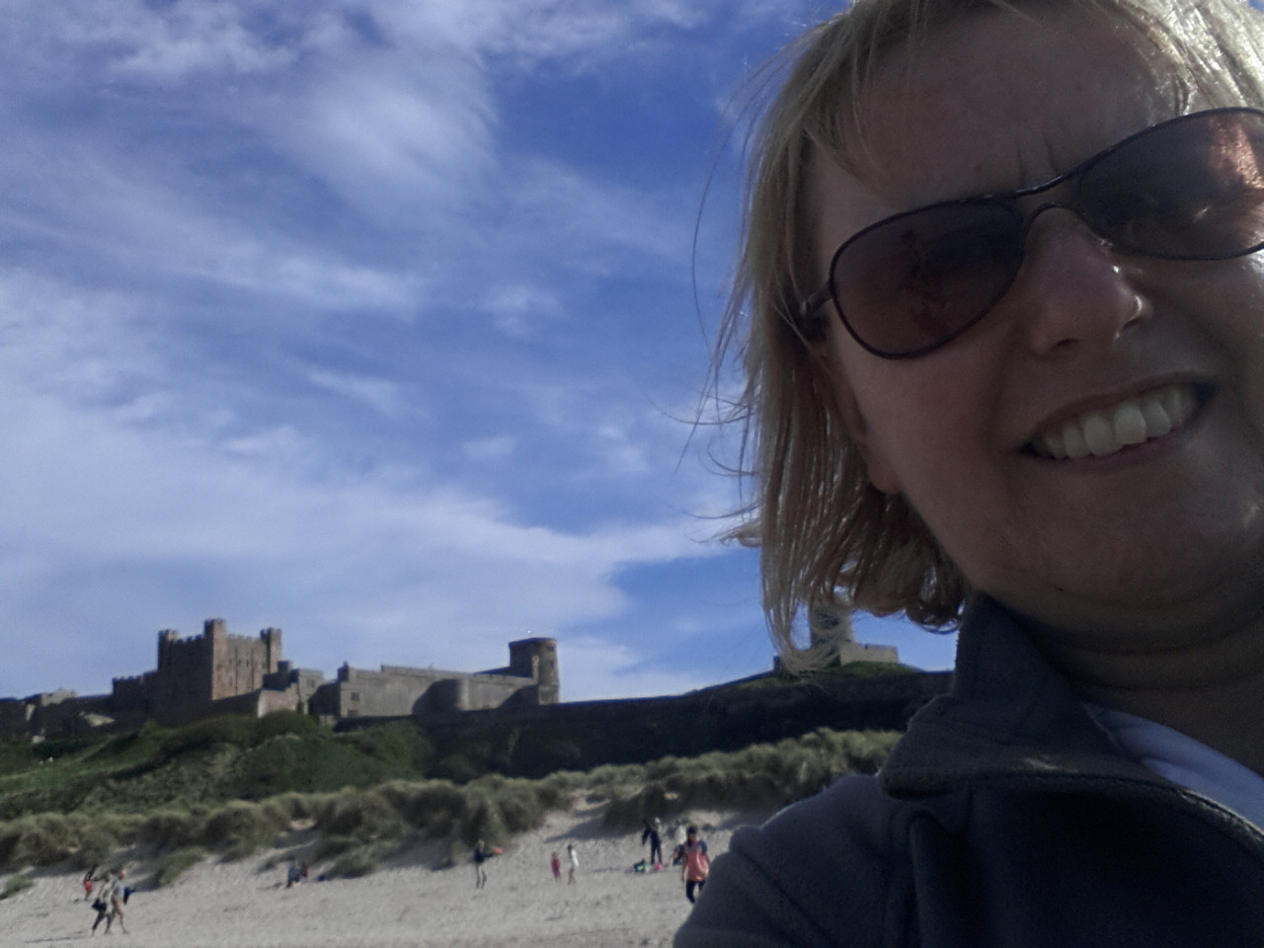

There are many more sights to see in our country
please come and visit!

