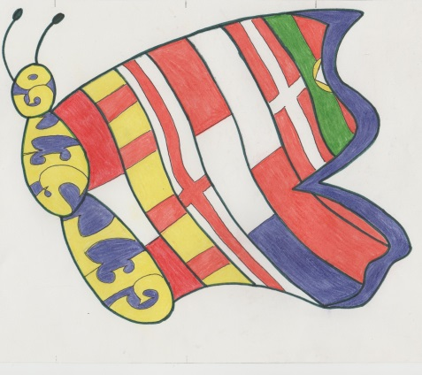
GET-SET-GO
TRAVEL GAME!
P | A | S | S | E | N | G | E | R | S
E | A | L | E | X | S | X | H | I | G
R | P | S | I | O | P | E | R | A | T
P | R | M | S | X | B | N | D | B | Y
I | I | C | H | E | C | K | - | I | N
B | S | L | I | D | N | I | L | M | I
O | A | D | O | M | I | G | D | A | E
N | S | G | A | T | O | L | E | R | V
I | A | L | B | E | R | T | N | T | E
T | I | C | K | E | T | O | M | A | S
O | M | N | I | N | S | P | I | L | O

DNI | PASSPORT | PASSENGERS | TICKET
CHECK-IN | PILOT | BAG

